|  |  |  |  |  |  |
| --- | --- | --- | --- | --- | --- |
| **Abdul Faiq** | | | | | |
|  | | | | | |
| **PROFILE:** | | | | | |
|  | | | | | |
| **Highly** **motivated and eager to contribute, I’m a recent** **matriculation student with a strong academic record and a keen interest in developing practical skills. While my formal work experience is limited. I pose a strong work ethic, excellent communications abilities, and a proven capacity for quick learning. I’m seeking an opportunity to apply my dedication and I am committed to exceeding expectation through hard work and a proactive approach.** | | | | | |
|  | | | | | |
| **EDUCATION:** | | | | | |
|  | | | | | |
| **2024-IX** | **From Board of Secondary education Karachi** | | | | **A1(Grade)** |
| **2025-X** | **From Board of Secondary education Karachi** | | | | **-** |
|  | | | | | |
| **SKILLS:** | | | | | |
|  | | | | | |
| **MS Office** | | | **Pending** | | |
| **Python** | | | **Pending** | | |
|  | | | | | |
| **ACADEMIC:** | | | | | |
|  | | | | | |
| **2023-2024** | | **IX(Comp-Science)** | | **Herald Citi School** | |
| **2024-2025** | | **X(Comp-Science)** | | **Herald Citi School** | |

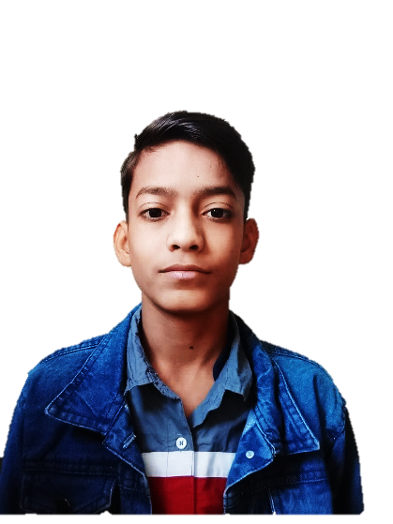

|  |
| --- |
| **CONTACT** |
| **Address** |
| KS-645/A, Block 10, Qalandarabad, Gulistan e Johor, Karachi. |
| **Phones** |
| 0315-2734138 |
| **Email** |
| Abdulfaiq369@gmail.com |
|  |
| **PROFESSIONAL** |
| * Able to work with team * Having a knowledge about MS office * Working in python, PowerPoint and excel |
|  |
| **PEFERENCES** |
| Available on request |